Creating and Updating Your Weebly Website

First Steps- Creating the Site

  - Go to Weebly for Education
    - education.weebly.com

  - Enter a username and password to access your site, and enter a valid email address. Be sure to write down your username and password so you don’t forget! Hit the “sign up” button.

  - The next thing you will see is a box prompting you to enter a title for your site. This name will be the title that people see when they look at your website.

  - The next step is to choose a website address. Choose Option A: subdomain of weebly.com and write your name, without spaces, in the box. Click “continue.” You have now created a website!

Site design

  - Click the Design tab at the top of the web page.

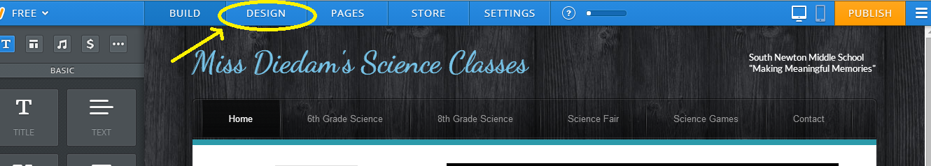
- Move the cursor to hover over the different images. The images are mini-versions of possible designs for your web page. Holding the cursor over an image for a few seconds will show you a larger sample of what that design looks like.

  - When you have chosen the design you want, click on the small image of the design at the top of the page. This will select the design you will be using for your website.

  - You can change the design of your site at any time.

  - You can change the picture at the top of the site at any time. Don’t worry if you don’t like the picture shown in the sample.
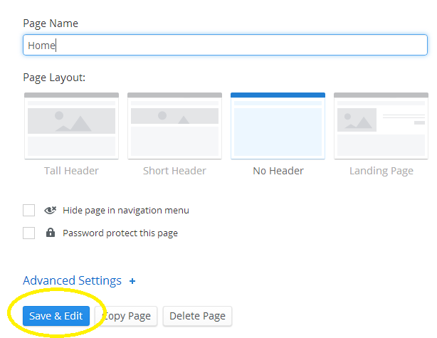
Adding more pages
- Scroll up to the top of the page, and click the Pages tab at the top of the site, right next to the Design tab.
- For each new page that you add:
- Click the New Page button
- In the box labeled Page Name, write the name of the page.
- Chose the Page Layout, and any other options
- Then click Save and Edit
Saving your work

  - At any time while working on your site, click the Publish icon at the top right of the page to save and publish your work.

  - A window will pop up telling you that your site has been published and asking if you would like to upgrade to a different site name. Just close out of this window, or you’ll have to pay money.
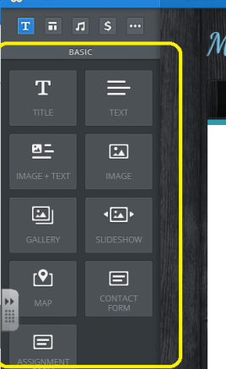

Adding and changing Text on your page

  - To add text, just drag the text box onto the page where you would like the text to go. You can also add Titles, columns, etc… to your page by this “dragging” method.
  - While you are editing text, a blue toolbar will appear that allows you to change the text, just like in a word application.
  - Take the time to look over all the items you can add with this toolbar.

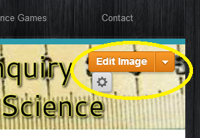
Working with Pictures
- Click on Edit Image to change a picture that is already on the page.
- Click Add Image and either search a photo or upload a photo.
- You can also add an image to your page by dragging the “image” button
located on the left hand side of your screen.

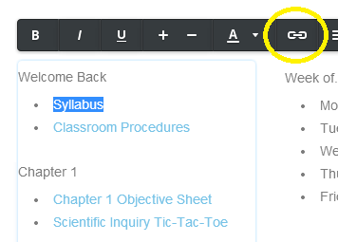
Working with Links and Attachments

  - Type the text that you want to serve as a link. Above I wrote “Syllabus”.

  - Highlight the text that you want to serve as the link using your cursor.
  - A blue toolbar at the top of the screen contains a chain. Click on the icon.
  - A window will open that says Link to: and offers a variety of locations. Chose which you chose to link your word to. (Note: you may choose to check the box that says Open link in new window and click Save.

Embedding into Weebly (ex: Prezi, Google Calendar, flashcards, etc…)
- Further directions can be found at http://kb.weebly.com/embed-audio-and-video.html

DON’T FORGET TO PUBLISH WHEN COMPLETE

