Name: ______________________
Energized Toy Cars
Problem: How does the mass of a toy car affect its potential/kinetic energy?
Hypothesis: If the car has ________ mass, then _____________________________________.
Procedure:
- Build a ramp 15-25 cm high using books or binders. Use a plastic track to complete the ramp.
- Measure and mark 1 meter from the start line. This will be the finish line.
- Release one car at the top of the ram from your start line and use a stopwatch to measure how long it takes until it crosses the finish line.
- Record the time. Do this three times.
- Next, use tape to add one washer to the car (it adds mass). Repeat steps 3-4.
- Continue releasing cars with up to four different washers in your data table.
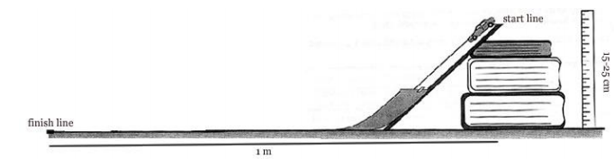
Data:
 | Trial 1 | Trial 2 | Trial 3 | Average
Car
Car with 1 washer
Car with 2 washers
Car with 3 washers
Car with 4 washers

Analysis:
- How did the travel time change as the mass of the car changed?
- How does the mass of a car affect how much energy it has? What evidence from the experiment makes you think this?
- What happened to the energy in the cars when they were released down the ramp?
- Where is the potential energy in the car equal to zero? At what point during the trial is the potential energy the greatest?
Conclusion: Look at the problem this experiment was studying and your hypothesis to make a conclusion. Did this experiment prove or disprove your hypothesis?

