Station 1:
Identify metal piece based on density.
Substance | Density (g/mL)
Zinc (Solid) | 7.13
Silver (Solid) | 10.50
Lead (Solid) | 11.35

Identify: Suppose that 273 g of one of the substances listed above displaces 26 mL of water. What is the substance?
- Zinc
- Silver
- Lead

Station 2:
Changes of States Cards

Instructions:
- There are three picture cards. Place them face down on the table.
- Each player picks a picture card.
- Shuffle the other cards and spread them face up on the table.
- Take turns top pick a card. If it describes your picture card, keep it. If not, you must give it to the player who needs it!
- The game continues until all players have completed their sets.

Station 3:
Physical/Chemical Changes
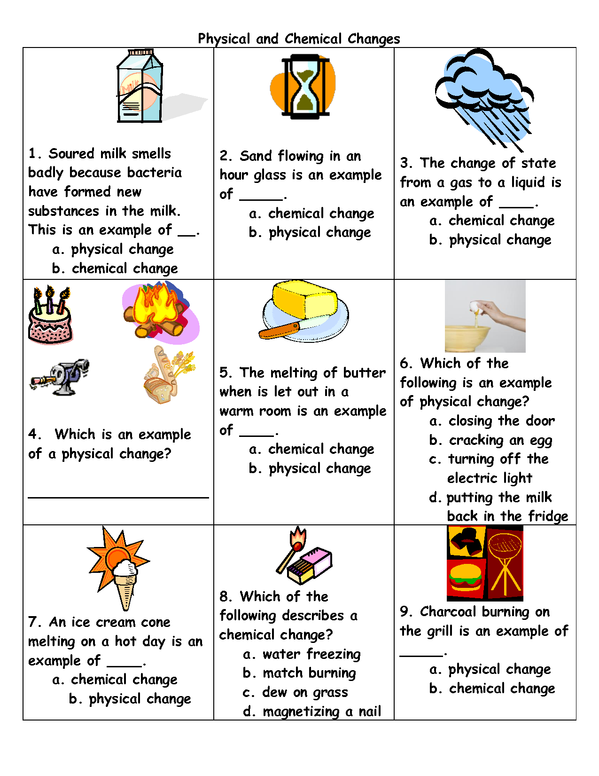

Station 4: ISTEP+ REVIEW
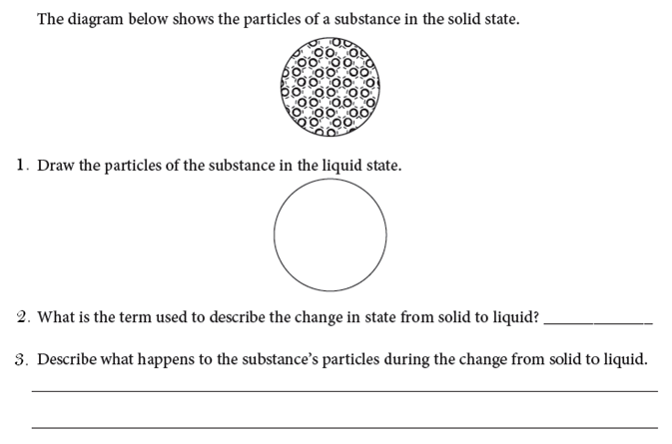
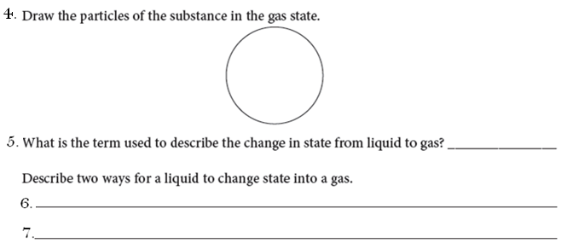
SCAN ANSWERS ABOVE

SCAN ANSWER

